A000-Afr-Paleo-Aterian-Middle Stone Age ‘tanged’ or ‘stemmed’ tools-100,000 BP

**Case No.: 6**

**Accession No.**

**Formal Label:** Afr-Paleo-Aterian-Middle Stone Age ‘tanged’ or ‘stemmed’ tools-100,000 BP

**Display Description:**

Aterian tools were a combination of two raw materials (stone point and wooden shaft) into a single composite tool for hafted knives or scrapers with alternating active edges, rather than hafted weapons.

**Accession Number:**

**LC Classification:**

**Date or Time Horizon:**

**Geographical Area:**

**Map:**

**GPS coordinates:**

**Cultural Affiliation:**

**Media:**

**Dimensions:**

**Weight:**

**Condition:**

**Provenance:**

**Discussion:**

**References:**

The evidence for an early invention and increasing prevalence of hafted tools is mounting, both in Europe, among Neandertals (e.g., [71,72]) and in Africa, among anatomically modern humans ([73,74]). In light of this evidence, it is perhaps more appropriate to treat the ‘Aterian question’ in terms of an early innovation in hafting, rather than in projectile use, or, indeed, in weapon use at all. And if that is the case, we must ask what prompted the invention of the hafting insert. It could be speculated that the invention of this distinguishing feature of the Aterian, the tang, was associated with a move into increasingly arid zones of the Sahara [19,20,75], where the lack of resin-bearing trees could have created the need for a hafting insert adapted for use with bindings (but see [73] for evidence of an increase in the use of resin for hafting in southern Egypt in the Upper Pleistocene and [76,77] for an ethnographic account of spear-hafting using resin in the Australian desert). It is as yet unclear if gum-yielding plants would have been available in the more arid zones of North Africa 100 thousand years ago, but it makes sense that a tang allows for an easier hafting using leather bindings, since it provides a less sharp and more regular surface to wrap around. The Aterian culture is found across North Africa (see Map) and is differentiated from the Mousterian and essentially defined by the presence of these tanged (stemmed) tools.

Aterian may be termed a Middle Paleolithic or Late Pleistocene flake-oriented technocomplex with a huge geographic area extending across North Africa and is defined by tanged lithics with similarities to Mousterian use of Le­vallois technique and some formal tools, resembling Upper Paleolithic technology, and, hence, is similarities to the Mousterian tradition, particularly for the presence of Le­vallois technique and a marked evolution of some formal tools, which re­semble elements of Upper Paleolithic technology, and, hence, is generally believed to have developed from of the Middle Paleolithic-Middle Stone Age (MP-MSA) ‘‘Mousterian’’ (e.g., Hahn 1984; Wengler 1997). The phenomenon of tanged lithic artifacts can be found in MP-MSA contexts on the Arabian Peninsula (McClure 1994). With regard to the central Sahara, the Aterian technocomplex is key for relationship to the Mousterian and to the dispersion of Homo sapiens from the Nile Valley, to the eastern Sa­hara, and to the Maghreb in the MP-MSA /Upper Paleolithic transition. The following Aterian dates suggest this **west to east flow of Aterian culture**:

103±3 ka (mean OSL) La Grotte des Contrebandiers on the Atlantic coast of Morocco with Moroccan Mousterian 116 3± ka with a hiatus of up to 13 ±3 ka. -Rabat-Moroco Barton-l-2009-OSL-dating-Dar-es-Soltan-I

47,000 ± 3200: Haua Fteah, a karstic cave in Cyrenaica, Libya,

Taforalt >40,000 (or Grotte des Pigeons), a cave located in the northern Oujda region of Morocco,

>39,900: Wadi Saoura, in southwestern Algeria,

>35,000 Bir el Ater, in far eastern Algeria the type site of the MP-MSA Aterian,

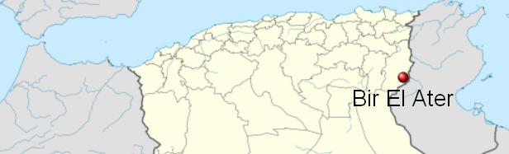

>30,000 Dar es Soltan the type site of the last 'glacial' period known as the Soltanian (Choubert, 1953; Choubert et al., 1956) a low calcarenite cliff on the Atlantic coast of Morocco near Rabat (33°58′44″N, 6°53′51″W)

.

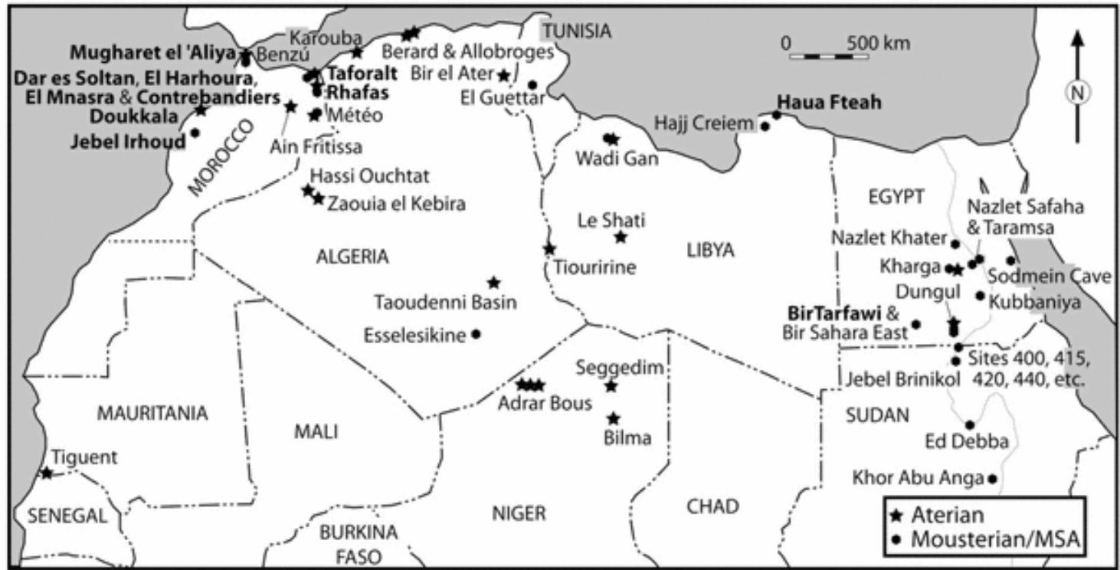

From

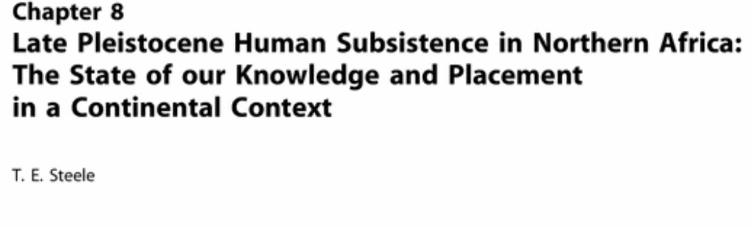

# Modern Origins 2012

|  |  |
| --- | --- |
| **Editors** | Jean-Jacques Hublin • Shannon P. McPherron |

T. E. Steele



Radiocarbon Dates of Aterian Sites in North Africa

Sites Age BP Lab. No. Reference

.

|  |  |  |  |
| --- | --- | --- | --- |
| Grotte des Contrebandiers | 103±3 ka OOOSL(OSL) |  |  |
| Grotte des Contrebandiers | 24,500 ± 600 | Gif-2582 | Delibrias *et al.* (1982) |
| Grotte des Contrebandiers | 23,700 ± 1000 | Gif-2585 | Delibrias *et al.* (1982) |
| Dar es Soltan | >27,000 | UCLA-678B | Ruhlmann (1951) |
| Dar es Soltan | >30,000 | UCLA-878A | Roche (1956) |
| Taforalt (layer 18) | >32,370 +2470/-1890 | Gif-2276 | Debenath (1992) |
| Taforalt (layer 19) | >34,550 +3200/-2280 | Gif-2277 | Debenath (1992) |
| Taforalt (base layer 19) | >40,000 | G if-2588 | Debenath (1992) |
| Taforalt (top layer 19) | >40,000 | Gif-2589 | Debenath (1992) |
| Taforalt (layer 23) | >40,000 | Gif-2279 | Debenath (1992) |
| Bir el Ater | >35,000 | MC-657 | Close (1980) |
| Wadi Saoura | >39,900 | 1-1787 | Chavaillon (1964) |
| Haua Fteah | 47,000 ± 3200 | GrN-2023 | McBurney (1967) |

McClure, H. A. (1994). A new Arabian stone tool assemblage and

notes on the Aterian industry of North Africa. Arabian Archaeology

and Epigraphy, 5, 1–16.

• 

## • [Single-grain OSL dating at La Grotte des Contrebandiers (‘Smugglers’ Cave’), Morocco: improved age constraints for the Middle Paleolithic levels](http://www.sciencedirect.com.libproxy.mit.edu/science/article/pii/S0305440311003128)

Original Research Article

• *Journal of Archaeological Science*, *Volume 38, Issue 12*, *December 2011*, *Pages 3631-3643*

• Z. Jacobs, M.C. Meyer, R.G. Roberts, V. Aldeias, H. Dibble, M.A. El Hajraoui

Date or Time Horizon: 100,000 BP

Geographical Area: North Africa

Cultural Affiliation: Aterian

Medium: Flint, Silicified limestone

Dimensions: H 1-3 in

Weight:

Provenance:

Condition:

Discussion:

References:



Map of Aterian sites (red circles). Base map from NASA http://www2.jpl.nasa.gov/srtm/africa.htm.

doi:10.1371/journal.pone.0029029.g002

Reference

Iovita R (2011) Shape Variation in Aterian Tanged Tools and the Origins of Projectile Technology: A Morphometric Perspective on Stone Tool

Function. PLoS ONE 6(12): e29029. doi:10.1371/journal.pone.0029029